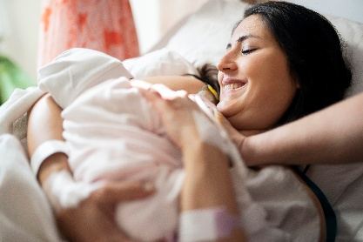  Breastfeeding Help for Nevadans | 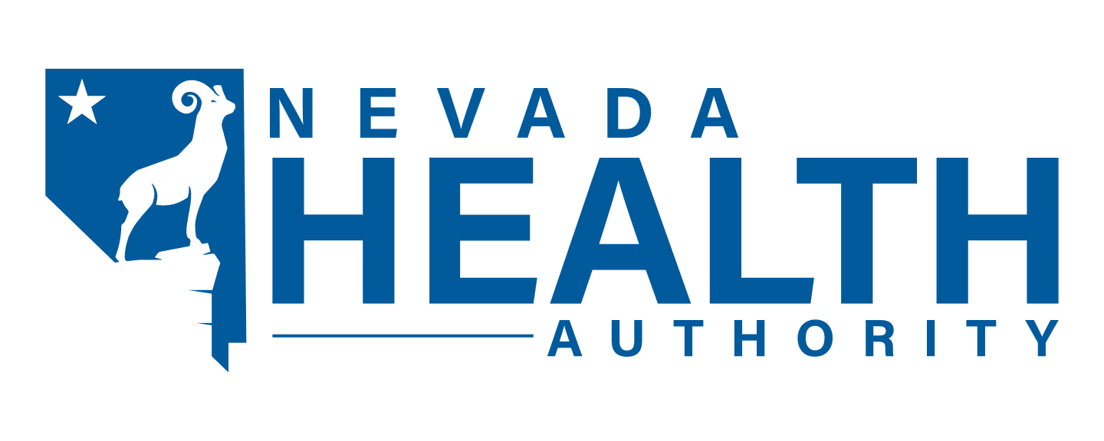  Nevada Medicaid Division  Medicaid@NVHA.nv.gov
What free help is available?  Counseling & emotional support  Essential breastfeeding supplies  Lactation consultation from experts  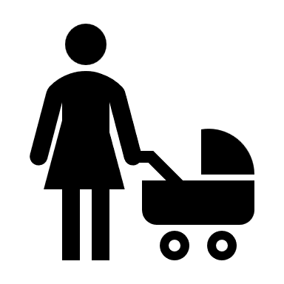 | Who can give me these services?  These providers can help you if they are enrolled in Medicaid:  • Primary care physicians  • Physician assistants  • Advanced practice registered nurses  • Nurse midwives  • Lactation consultants when working in consultation with the Medicaid-enrolled health care providers above
Nevada Medicaid is proud to support infants and their families by offering quality, culturally appropriate breastfeeding resources.  Questions? Write to: Medicaid@NVHA.nv.gov  This flyer meets the requirements of AB266 to comply with NRS 422.27174, 422.27178, and 422.27179. | Talk to your Nevada Medicaid provider today!  Find out more at: NevadaBreastFeeds.org  